INTEGRATING LIVE WEBSITE DATA WITH DNIF

A Lot of websites provide real time data using APIs. These APIs can be integrated with DNIF. A Diagrammatic Representation of the process is shown below.

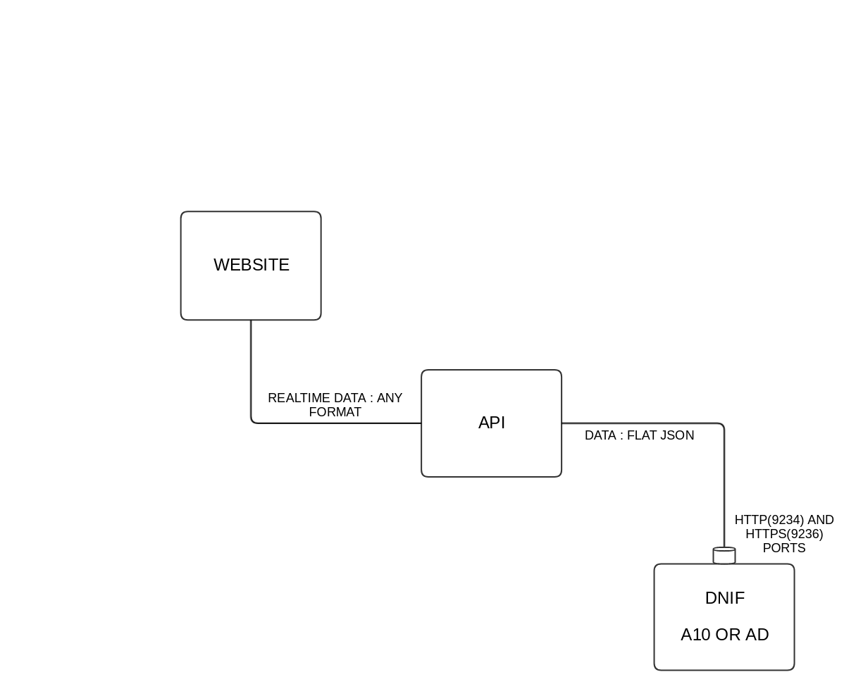

Websites provide real time data which could be of any format. APIs are available that forward this data that can be used for various purposes.

To forward the APIs data to DNIF we must first make sure that the data is in the flat json format. This data is then sent to DNIF through the HTTP(9234) and HTTPS(9236) Listener Ports.

This Data is then stored and suitable queries can be fired in order to analyze the data from the APIs.

For Example,

There is an API which provides information about the air pollution along with the geographical details of a particular location , with this information we could represent relevant data regarding the pollution in a map.